Blue Zone

What is the Blue Zone?
The blue zone is used when a person is feeling low states of alertness or arousal.
When you’re in the blue zone you may be feeling down – sad, sick, tired, or bored. You’re still in control, as you are in the yellow zone, but with low energy emotions.

How would your child behave in the Blue Zone?
- absence of feelings
- irritability
- lack of pleasure
- lack of motivation
- tearful
- withdrawn
- difficulty in concentrating
What coping strategies do we implement in school?
- Exercise
- Alerting sensory breaks
- Reflecting on what makes us happy
- Talking to our teachers and friends

What strategies can you use at home?
- Listen to upbeat music
- Complete some cardio based exercise
- Get up, get showered and get dressed
- Jump on a trampoline
- Talk to a friend
- Do something creative
- Cuddle or play with pets.
- Go for a walk
- Plan a fun activity
- Look through old photographs or snap some new ones.
- Re-watch a funny or inspiring YouTube video.
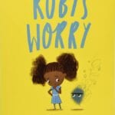
Stories to read at home
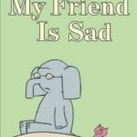
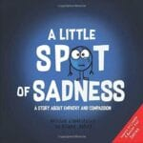

- Lucy’s In Lockdown – CBeebies style reading – YouTube
- Lucy’s Blue Day

